COMP70066 – Software Engineering Principles and Practices
Interface Design (Wireframes)
Scenario 3 — Restaurant Review Portal (Colombo, Kandy, Galle) — Simplified Design
Stage 3 Deliverable: Requirements & Design

1. Purpose and Scope
This document completes the Stage 3 design set alongside the Functional Design (UML), Data Flow Diagrams (DFD) and Entity Relationship Diagram (ERD) documents. It presents low-fidelity wireframes for every page identified from the use case diagram: six Customer-facing pages (mobile-first, 375px base width) and five Admin-facing pages (desktop/tablet, 1024px width), matching the responsive approach set out in the Ruchi design system.
Wireframes are deliberately grayscale and free of final copy, colour or branding — their purpose is to agree page structure, navigation and the placement of every field and control before visual design begins. Each wireframe is annotated with the page name, viewport and actor, and is followed by a short note on the controls shown and which use case(s) and data-model fields it covers.

2. Page Inventory
The eleven pages below map directly onto the actors and use cases in the Functional Design (UML) document, and every field shown reads or writes one of the six tables in the ERD.
- Customer-facing (mobile-first): Register/Log In, Home, Search & Filter Results, Restaurant Detail, Write a Review, My Account.
- Admin-facing (desktop/tablet-first): Admin Dashboard, Manage Restaurants, Manage Menu Items, Moderation Queue, Respond to a Review.

3. Customer-Facing Pages

3.1 Register / Log In
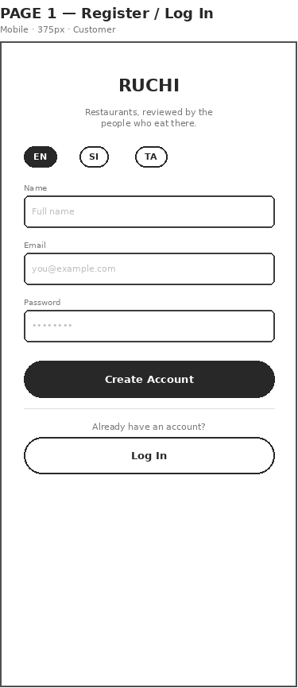
Figure 1 — Register / Log In (same layout on mobile and PC — a standalone, nav-free form)
Covers: UC "Register / Log In"; writes User (name, email, password_hash, language) and reads it back on login.
Notes: The language switcher sets User.language at the point of registration so every later page can localise immediately.

3.2 Home / Landing
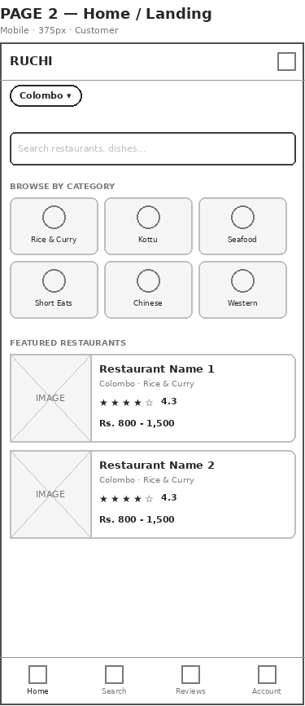
Figure 2a — Home / Landing (mobile, bottom tab bar)
Covers: Entry point into UC "Search & Filter Restaurants"; city selector scopes every result to Colombo, Kandy or Galle.
Notes: Category tiles are a shortcut into Search & Filter Results with the category pre-applied, rather than a separate use case.
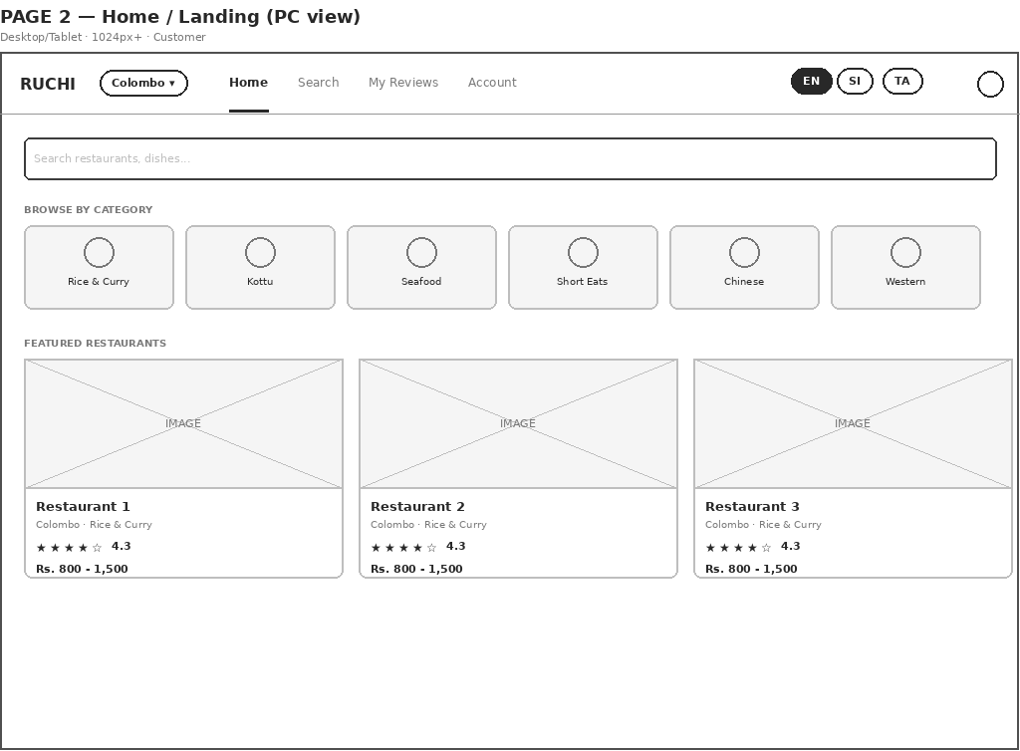
Figure 2b — Home / Landing (PC view, top nav — BottomTabBar is removed entirely at this width)

3.3 Search & Filter Results
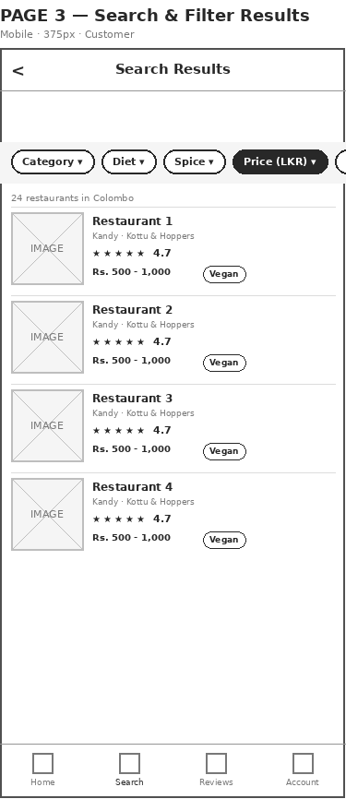
Figure 3a — Search & Filter Results (mobile, bottom tab bar)
Covers: UC "Search & Filter Restaurants"; filter chips map to category, dietary attributes, spice level, price band and sort.
Notes: Price band and the star rating shown on each card are both computed at query time (Restaurant/MenuItem.price_lkr and approved Review rows) — neither is stored.
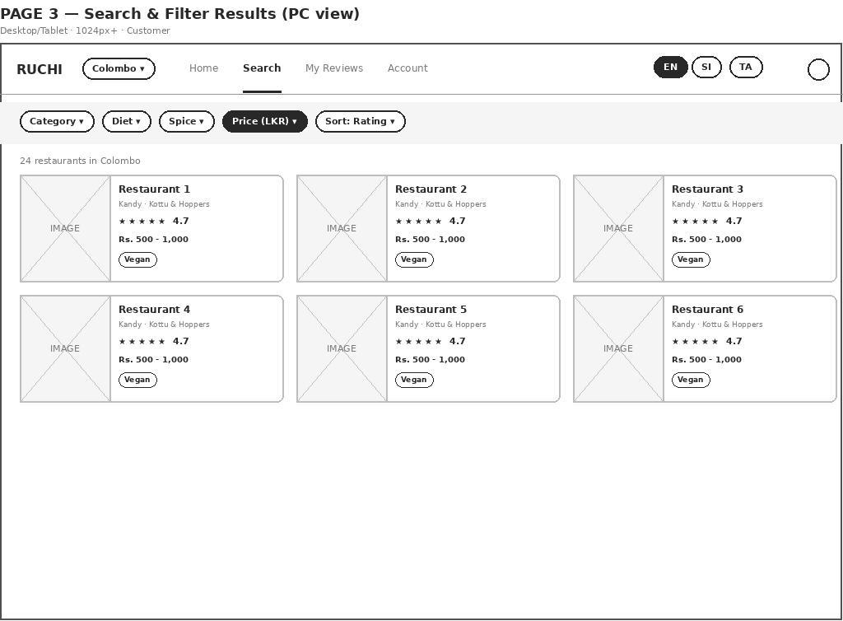
Figure 3b — Search & Filter Results (PC view, top nav; filter bar unwraps to one row, results lay out as a grid)

3.4 Restaurant Detail
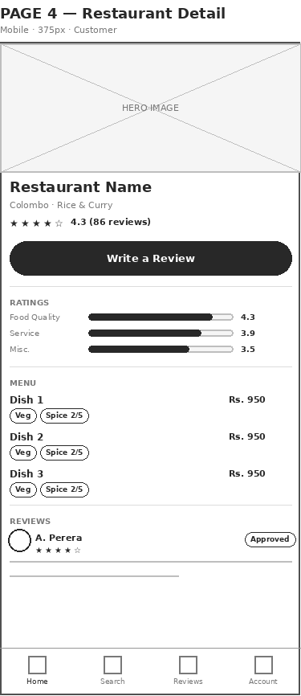
Figure 4a — Restaurant Detail (mobile, bottom tab bar)
Covers: UC "View Restaurant & Menu"; menu rows show MenuItem.price_lkr, dietary tags and spice_level; reviews shown are status = Approved only.
Notes: The three rating bars are the average of food_quality_rating, service_rating and misc_rating across all Approved reviews for this restaurant.
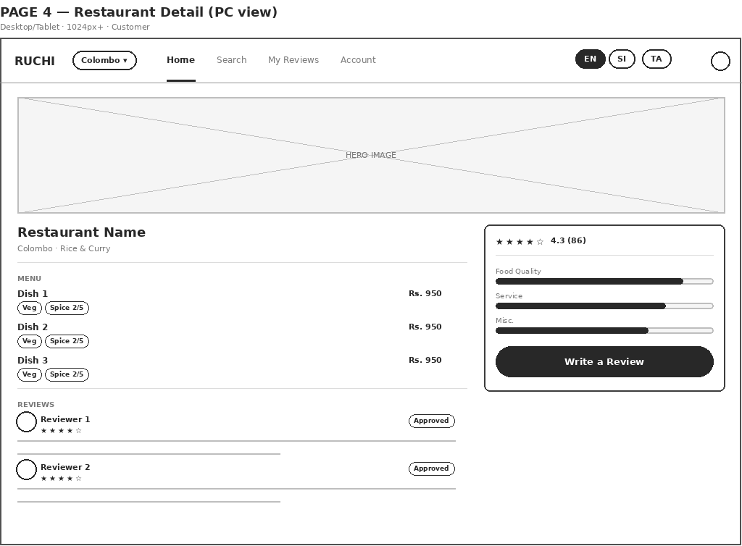
Figure 4b — Restaurant Detail (PC view, top nav; menu/reviews and the rating + Write a Review panel split into two columns)

3.5 Write a Review
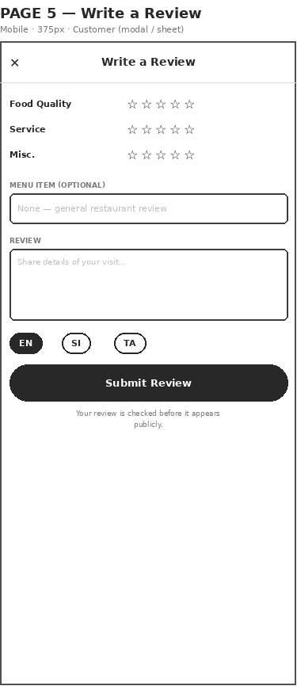
Figure 5 — Write a Review (modal/sheet, same on mobile and PC)
Covers: UC "Submit Review"; writes a new Review row with status = Pending.
Notes: The optional menu-item link is Review.item_id (nullable) — left as "None" the review is treated as a general restaurant review. This opens as a full-screen sheet on mobile and a centred modal on PC, over whichever page it was triggered from — no separate desktop layout is needed.

3.6 My Account
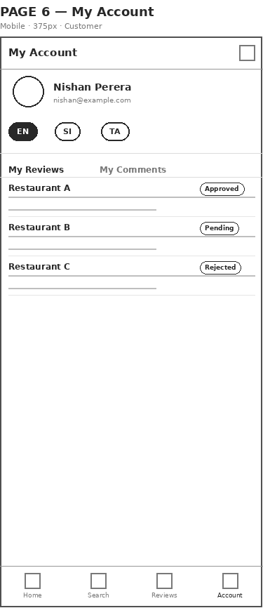
Figure 6a — My Account (mobile, bottom tab bar)
Covers: Lets a Customer see their own Review and Comment rows across all three statuses (Pending / Approved / Rejected) — the one place unapproved content is shown back to its author.
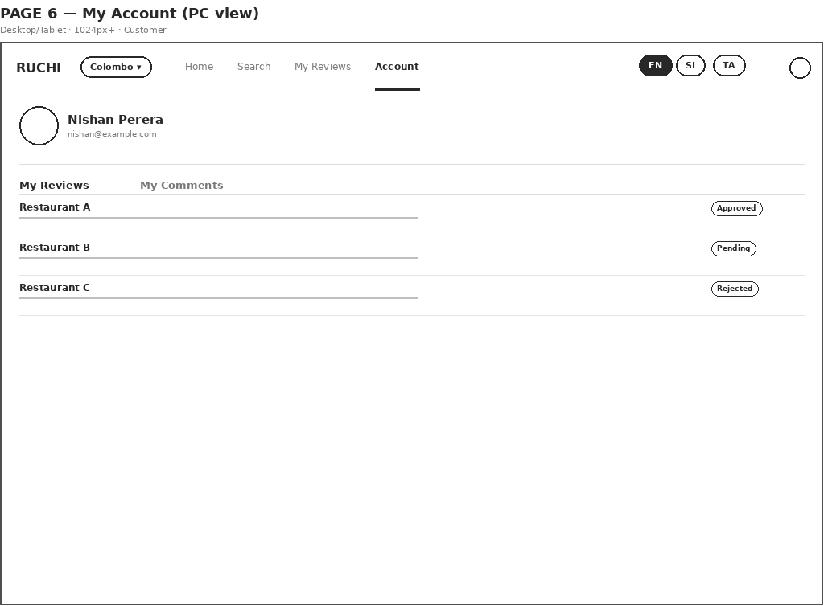
Figure 6b — My Account (PC view, top nav)

4. Admin-Facing Pages

4.1 Admin Dashboard
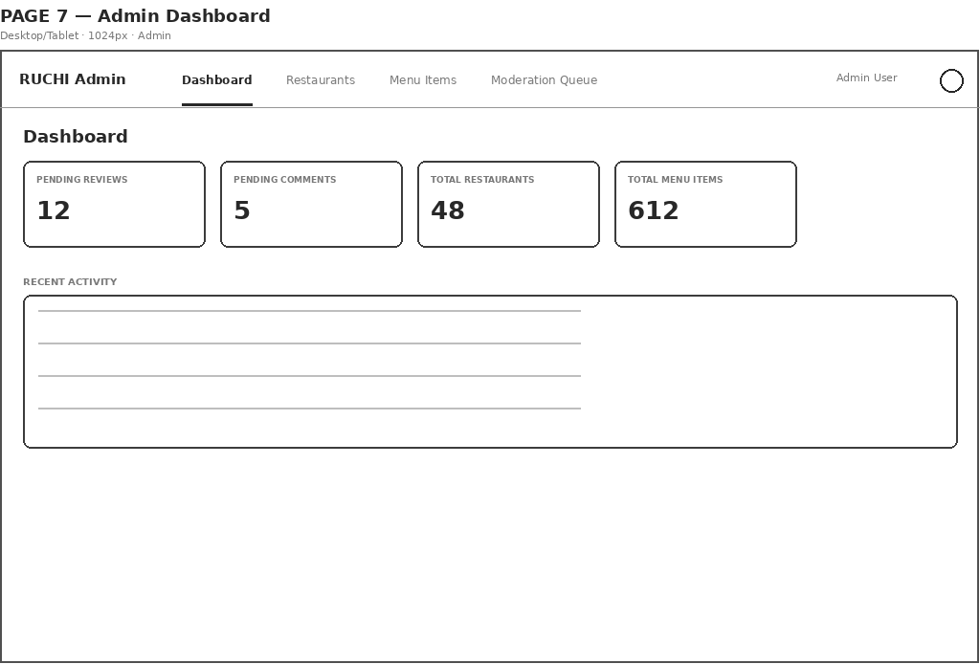
Figure 7 — Admin Dashboard (desktop/tablet)
Covers: Landing page for the Admin actor; the two moderation counts link straight into the Moderation Queue (Page 10).

4.2 Manage Restaurants
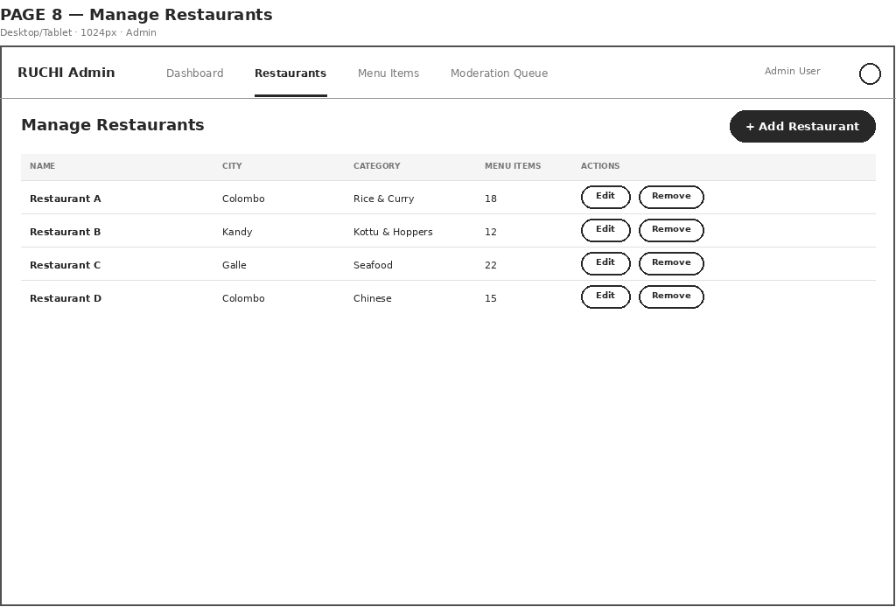
Figure 8 — Manage Restaurants (desktop/tablet)
Covers: UC "Manage Restaurants, Menu & Prices"; add/edit/remove rows in the Restaurant table.

4.3 Manage Menu Items
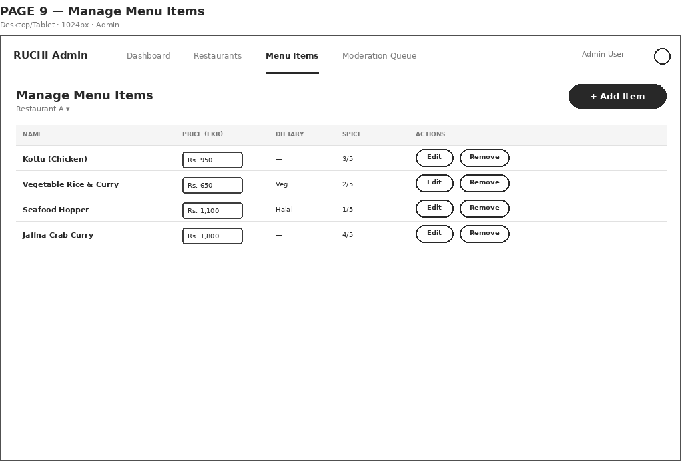
Figure 9 — Manage Menu Items (desktop/tablet)
Covers: UC "Manage Restaurants, Menu & Prices"; price is shown as an inline editable field, directly satisfying "costs... should be able to be changed in the database".

4.4 Moderation Queue
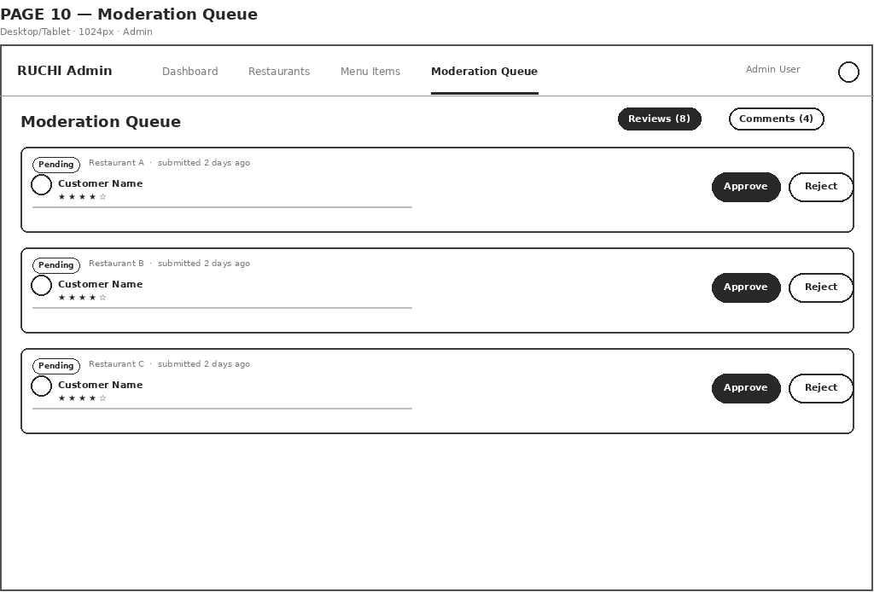
Figure 10 — Moderation Queue (desktop/tablet)
Covers: UC "Moderate Reviews & Comments"; Approve/Reject write Review.status / Comment.status. The Reviews/Comments toggle switches which data store the list reads from.

4.5 Respond to a Review
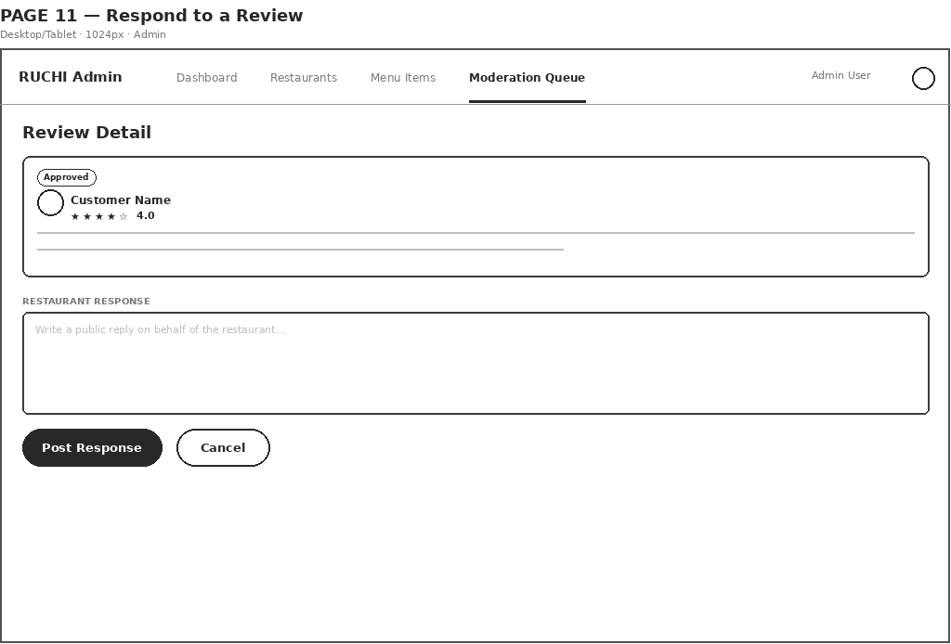
Figure 11 — Respond to a Review (desktop/tablet)
Covers: UC "Respond to a Review"; writes the single Response row for this review (review_id FK, unique) — the form does not appear once a response already exists.

5. Navigation Summary
Both Customer and Admin pages switch navigation pattern by viewport, per the Ruchi design system's breakpoints:
- Customer pages — a persistent bottom tab bar (Home / Search / My Reviews / Account) on mobile. At the 640px breakpoint the bottom tab bar is removed entirely and replaced by a top navigation bar (logo, city selector, inline links, language switcher, account icon), as shown in the PC view of each page above.
- Admin pages — always a top navigation bar (Dashboard / Restaurants / Menu Items / Moderation Queue), since back-office work is desktop/tablet-first; this also keeps the full page width available for tables and forms rather than losing a column to a sidebar.
Register/Log In and Write a Review are the two exceptions: both are stand-alone, nav-free surfaces (a form and a modal/sheet respectively) and so render identically regardless of viewport.

